Aryan Sai Venkat M

230701040 CSE A

Exp No:10a Best Fit

# PROGRAM

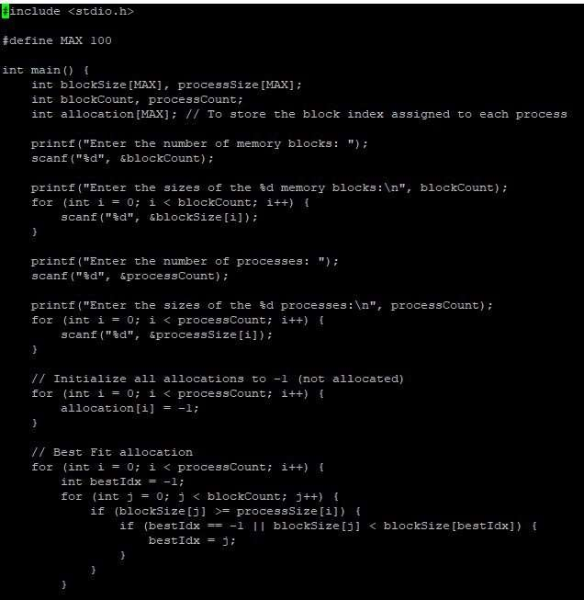

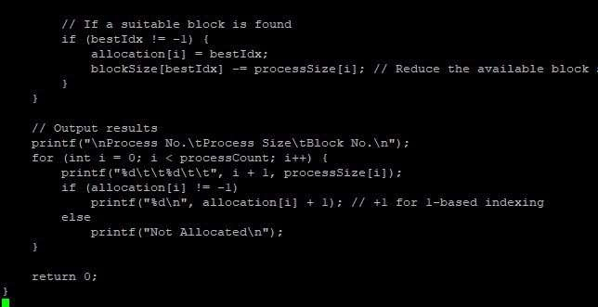

# OUTPUT

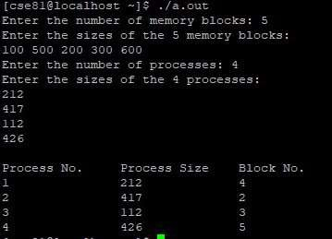

Exp No:10b Best Fit

# PROGRAM

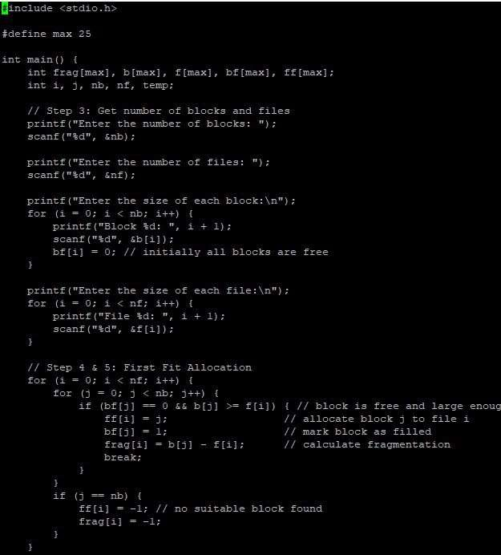

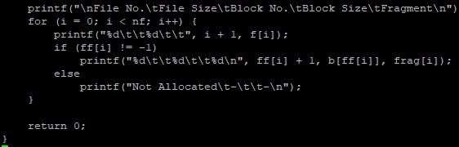

# OUTPUT

